**SKILL LEARNT: TDD USING JUNIT 5 AND MOCKITO (WEEK 2)**

**EXERCISES 1: MOCKITO EXERCISES (MOCKING AND STUBBING)**

The project name created is JUnit. The package created is tests. Inside tests, there are three classes that is created is ExternalApi.java, MyService.java, MyServiceTest.java.

**ExternalApi.Java**

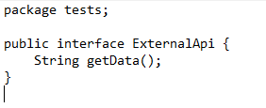

**MyService.java**

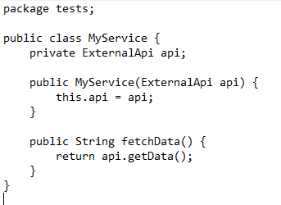

Then a JUnit test case is created by selecting JUnit 4 test and then adding JUnit 4 library to the build path. A MyServiceTest.java Class is created through which the test cases will be checked.

**MyServiceTest.java**

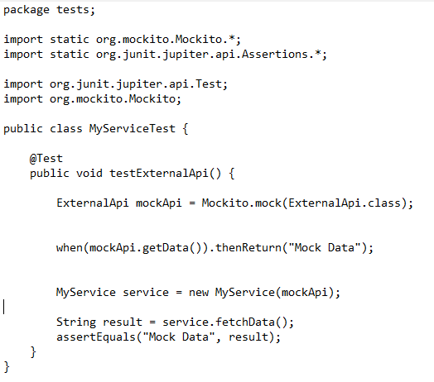

**OUTPUT:**

The test cases passed successfully showing 0 errors.

**EXERCISE 2: VERIFYING INTERACTIONS**

The project name created is JUnitDemo. The package created is tests. Inside tests, there are three classes that is created is ExternalApi.java, MyService.java, MyServiceTest.java.

**ExternalApi.java**

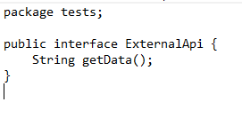

**MyService.java**

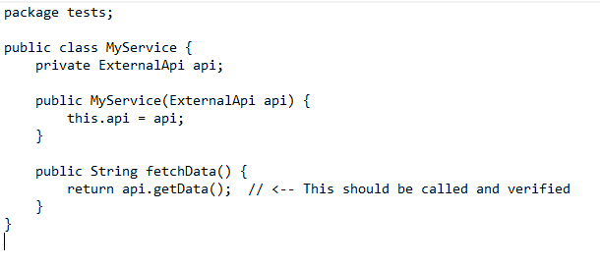

Then a JUnit test case is created by selecting JUnit 4 test and then adding JUnit 4 library to the build path. A MyServiceTest.java Class is created through which the test cases will be checked.

**MyServiceTest.java**

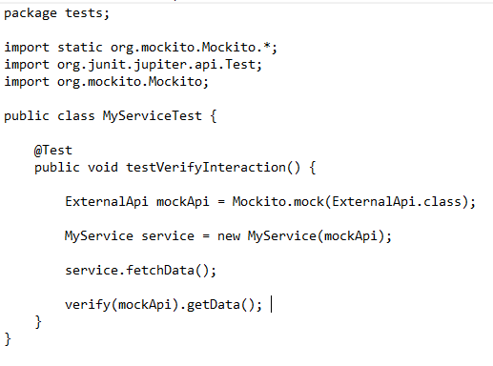

**OUTPUT:**

The test cases passed successfully showing 0 errors.

**EXERCISE 4: SL4J LOGGING EXERCISES (LOGGING ERROR MESSAGES AND WARNING LEVELS)**

First we will create a Maven project where I will insert Group id as com.example and artifact id as LoggingApp.

In the pom.xml we have to add the dependency as

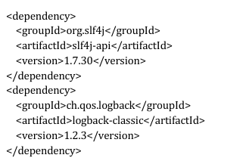

Next we will create a package named com.example and an class inside it named as LoggingExample.java

**LoggingExample.java**

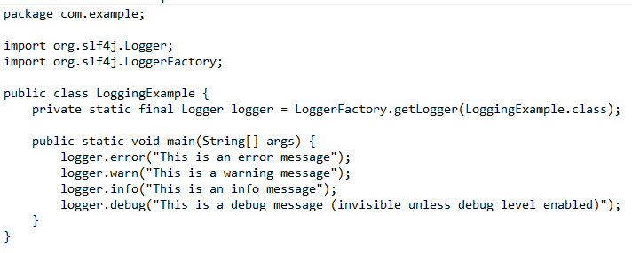

**OUTPUT:**

